Town of Rindge

30 Payson Hill Road
Rindge, NH 03461

APPLICATION FOR EMPLOYMENT
We consider applications for all positions without regard to race, color, religion, creed, sex, national origin, disability, sexual orientation, citizenship status or any other legally protected status.
(PLEASE PRINT)
Position(s) Applied For |  | Date of Application
How Did You Learn About Us?
____ Advertisement ____ Friend _____ Inquiry _____Employment Agency _____Relative ____ Other___________________

Last Name First Name Middle Name

Address Number Street City State Zip Code

Telephone Number(s) (preferred #)  (h)_______________ c)____________________ | Social Security Number (voluntary)

Best time to be contacted __________________am or ________________ pm

If you are under 18 years of age can you provide required proof of your eligibility to work? ______________________

Have you ever filed an application with the Town of Rindge before? If Yes, date_______________________________

Have you ever been employed with us before? If Yes, date ________________________________________________

Do any of your friends or relatives, work for the Town of Rindge? ___________________________ If Yes, state name, relationship and location ________________________________

Are you currently employed? ____________________________________________________

May we contact your present employer? ___________________________________________

Are you prevented from lawfully becoming employed in this country because of Visa or Immigration Status?
Proof of citizenship or immigration status will be required upon employment ________________________

Have you ever been convicted of a felony? __________________________

Date available for work ____________ What is your desired salary range? __________________

Are you available to work: ______ Full Time (Please indicate 1 2 3 shift)
______ Part Time (Please indicate Mornings Afternoon Evenings)
______ Temporary (Please indicate dates available __________ to________)

Are you currently on “lay-off” status and subject to recall? ____________________________ Can you travel if a job requires it? _______________________

EDUCATION
School | Name and Address of School | Course of Study | Number of Years Completed | Diploma/Deg  ree
High School
Undergraduate College
Graduate/Professional
Other (Specify)

ADDITIONAL INFORMATION
State any additional information you feel may be helpful to us in considering your application, including any job related experience.

__________________________________________________________________________________________________________

Note To Applicants: Do Not Answer This Question Unless You Have Been Informed About The Requirements Of The Job For Which You Are Applying.

Can you perform the essential functions of the job, for which you are applying, either with or without a reasonable accommodation? _____ YES _____NO
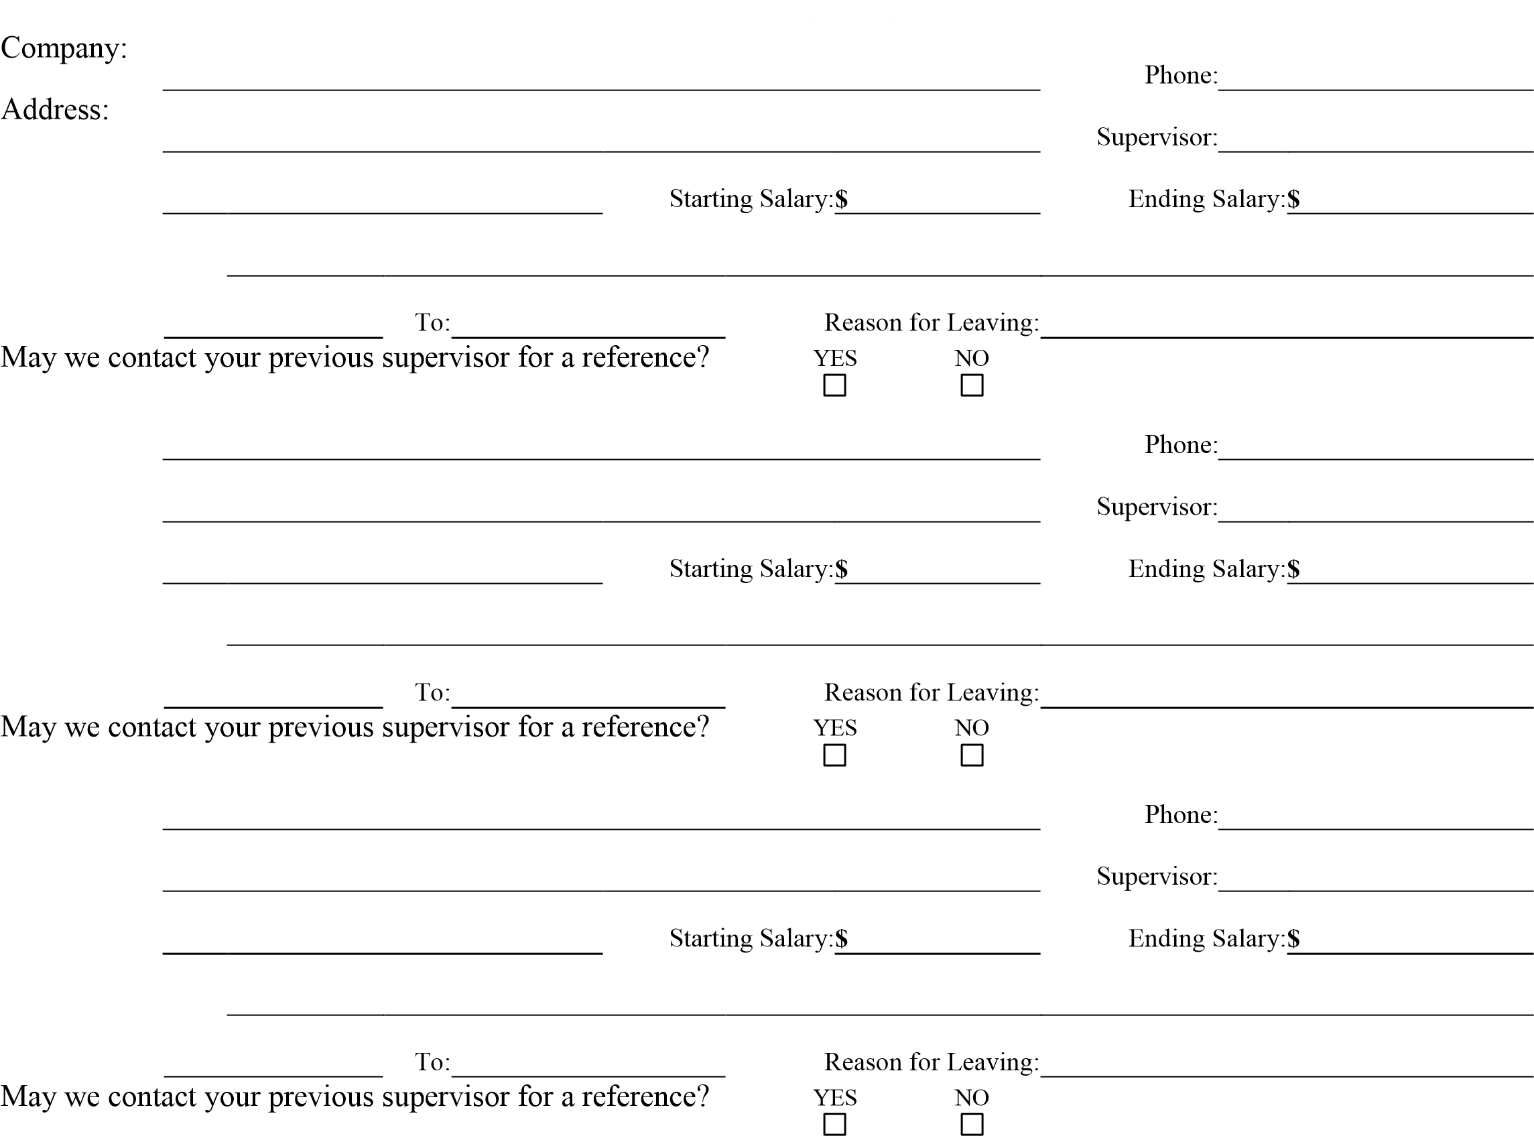
Job Title:
Responsibilities:
From:
Company:
Address:
Job Title:
Responsibilities:
From:
Company:
Address:
Job Title:
Responsibilities:
From:

References

Please list three professional references.

Full Name:

Relationship:

Company:

Phone:

Address:

Full Name:

Relationship:

Company:

Phone:

Address:

Full Name:

Relationship:

Company:

Phone:

Address:

APPLICANTS STATEMENT
I certify that answers given herein are true and complete.

I authorize investigation of all statements contained in this application for employment as may be necessary in arriving at an employment decision. This application for employment shall be considered active for a period of time not to exceed 45 days. Any applicant wishing to be considered for employment beyond this time period should inquire as to whether or not applications are being accepted at that time.

I hereby understand and acknowledge that, unless otherwise defined by applicable law, any employment relationship with this organization is of an
“at will” nature, which means that the Employee may resign at any time and the Employer may discharge Employee at any time with or without cause. It is further understood that this “at will” employment relationship may not be changed by any written document or by conduct unless such change is specifically acknowledged in writing by an authorized executive of this organization.

In the event of employment, I understand that false or misleading information given in my application or interview(s) may result in discharge. I understand, also that I am required to abide by all rules and regulations of the Employer.

_______________________________ _______________________
Signature of Applicant Date

